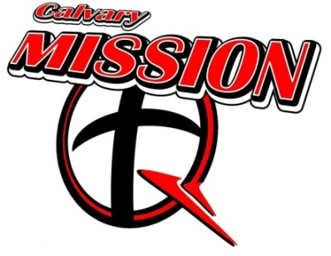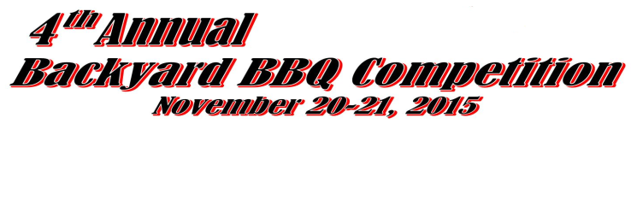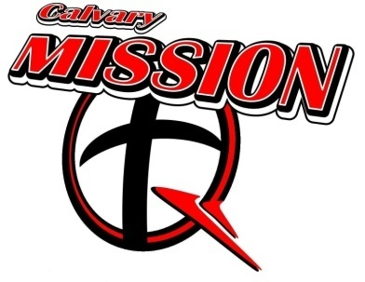

Natchez Trace Harley Davidson,
Alabama BBQ Trail EventaLA
KCBS
SANCTIONED
595 Hwy 72 W. Tuscumbia, Alabama
Alabama BBQ Trail Event, Sanctioned by KCBS

* * * $2500 PRIZE MONEY * * *
* * * Grand Champion $750 * * * Reserve Grand Champion $500 * * *

Backyard Division Only– Entry Fee $150
(Entry Fee $175 after October 30)

(Allotted Space is 20’ x 20’ with 20 AMP Power and Water)
(NO 30 AMP POWER SUPPLIED)
People’s Choice – Boston Butt provided by Calvary Mission-Q

T Shirts $15 Each: Sizes: ___ S ___M ___L ___XL ___2XL ___3XL

*Chicken * Pork Ribs (Loin or Spare) * Pork (Shoulder or Butt) *

Team Name:___________________________________________________________________
Team Contact:______________________________Phone No.:___________________________
Address:_______________________________________________________________________
City, State, Zip:__________________________________________________________________
EMAIL:________________________________________________________________________

ENTRY FEES: ___ $150 Backyard Division ___ People’s Choice
Pre-Order Friday Night Fish Fry Tickets: ______ $10Each
(___ Fish ___ Chicken ___ Shrimp)
PAYMENT MUST ACCOMPANY APPLICATION
Make check payable to: Calvary Baptist Church,
Mail To: Calvary Baptist Church, 601 N. Main St. Tuscumbia, AL 35674

FOR MORE INFORMATION CONTACT:
Wesley Burden 256-762-3592, wburden@appliedchemical.com

Waiver of Liability:
Calvary Baptist Mission Q, including its officers, sponsors and/or associates and the contestants, including parents, and/or legal representatives, agree that the Calvary Baptist Mission Q, will in no case be responsible for any loss, damage, or injury regardless of how much loss, damage or injury is occasioned, and indemnify and save harmless The Calvary Baptist Mission Q from any and all claims, suits and or judgments including the cost for defense of and such claim and/or suit by the Calvary Mission Q brought by anyone as a result of any loss, damage or injury to any person or property, occasioned by any action or inaction of contestant either solely or in conjunction with the Calvary Mission Q. Further, I hereby grant full permission to the Calvary Mission Q and/or agents authorized by them, to use any photographs, videotapes, motion pictures, recordings or any other record of the event for any legitimate purpose. I have read and agree to
abide by the rules governing the BBQ cook-off.

Signature:________________________________________________

